Exercise: Spring Data JPA with Hibernate Part 1

1 Create an Employee Entity which contains following fields

Name

Id

Age

Location

Answer:

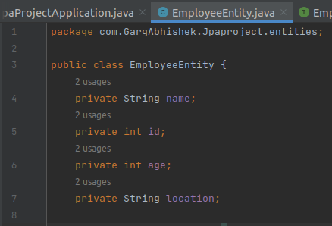

2 Set up EmployeeRepository with Spring Data JPA

Answer: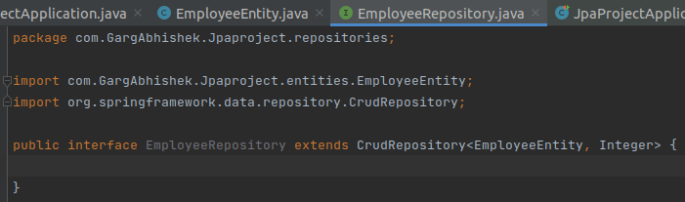

3 Perform Create Operation on Entity using Spring Data JPA

Answer:

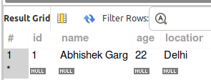

4 Perform Update Operation on Entity using Spring Data JPA

Answer:

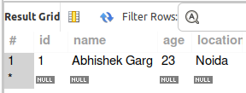

5 Perform Delete Operation on Entity using Spring Data JPA

Answer:

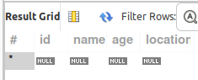

5 Perform Read Operation on Entity using Spring Data JPA

Answer:

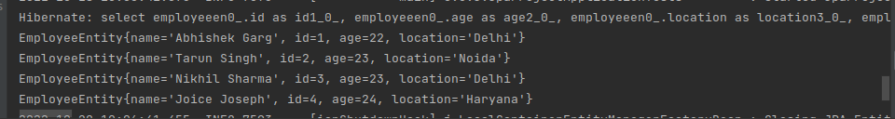

6 Get the total count of the number of Employees

Answer:



7 Implement Pagination and Sorting on the bases of Employee Age

Answer:

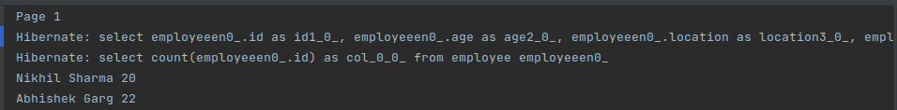

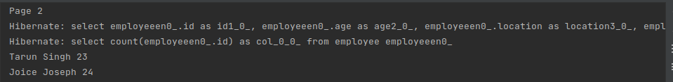

8 Create and use finder to find Employee by Name

Answer:



9 Create and use finder to find Employees starting with A character

Answer:



10 Create and use finder to find Employees Between the age of 28 to 32

Answer:

